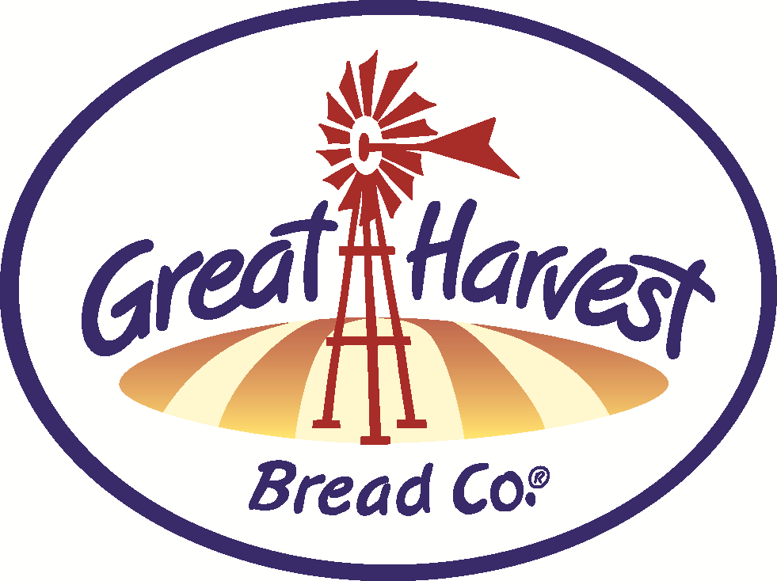
HANDCRAFTED

Breads & Goodies


BAKE SCHEDULE OCTOBER

If you give a Mouse a Cookie...make it huge! Share a
pack of GH cookies with a neighbor. Order ahead to
purchase two six-packs and third one is free!
Caramel Apple Bread is a unique quick bread on a limited run! Apple pieces and caramel drops infused into this wonderful sweet loaf.
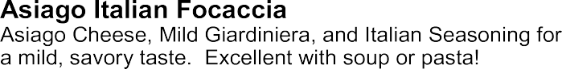

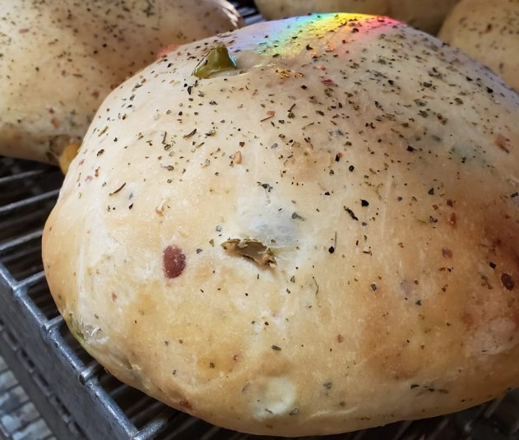

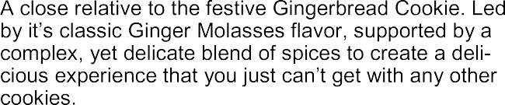
Try our amazing sandwiches with a tray of our delicious sweets for your next team meeting or group get-together.

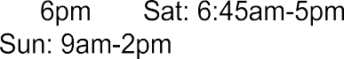

BREADS (special bake days indicated)

Cinnamon Chip & Monkey Bread
Chips baked right into the dough!


Honey Whole Wheat
Simply whole wheat, honey, water, yeast & salt.

Old Fashioned White
Exceptional white bread from scratch!

Dakota
Nutritious seeds add that special crunch to our whole grain wheat dough!

Cheddar Garlic
Packed with cheddar and baked kick of garlic. Also try our Jalapeno variation for some added heat!

Low Carb Whole Wheat
Low calorie, low carb, whole grain & high protein!

Low Carb Nut & Seed
Added nuts & seeds (more protein!)

Oregon Herb -TUE & FRI (bake day)
Tastes like an “Everything” bagel!
9 Grain-MON & THUR (bake day) - for those that want more!

Sourdough - TUE & FRI (bake day)
Challah - FRI (bake day)
Enriched & braided - perfect French Toast!

Virginia Rolls
Light and buttery with potato & light wheat

WEEKEND BAKER'S SPECIALS:

Pizza Bread - (Oct 2nd - 5th)
Three varieties to choose from; Meat, 3-Cheese, or Spinach & Garlic...all with pizza sauce & spices rolled into the dough!

Mediterranean Loaf- (9th -12th)
A new test creation from our bake crew to try! Gruyere cheese, sundried tomatoes and caramelized onion form the perfect savory blend to accompany your soup, pasta or other heartier dishes this Fall.

Orange Blossom - (Oct 16th - 19th)
Pureed navel oranges baked in the dough with a sweet, crunchy hat!

White Chocolate Cherry Swirl - (23rd - 26th)
Super Decadent...a customer favorite!

Pizza Bread - (30th - Nov 2nd)
Happy Halloween Weekend! A spooky encore!
SANDWICH SPECIALS
Toasted Grilled Cheese

Gooey, melted cheese hugged by Wheat, White or Dakota bread with a hint of our own garlic herb spread.
Buy this sandwich and get a bag of chips FREE!

SWEETS
CINNAMON ROLLS (they’re HUGE!)

SCONES Best in Town!
Blueberry - Best Seller!
Cinnamon Chip/Chocolate Chip
Savory Ham & Cheddar (nice breakfast)

COOKIES

Oatmeal Choc. Chip & Snickerdoodle Ginger Molasses
Pumpkin Spice Cookie Cherry Almond Shortbread

BARS- Pumpkin Spice!

MUFFINS - Pumpkin

Carrot

GLUTEN FREE
Bread - Avail. Frozen daily

Teacakes and Cookies

This symbol means it's made with our from-scratch, whole grain flour that we stone mill fresh daily!

