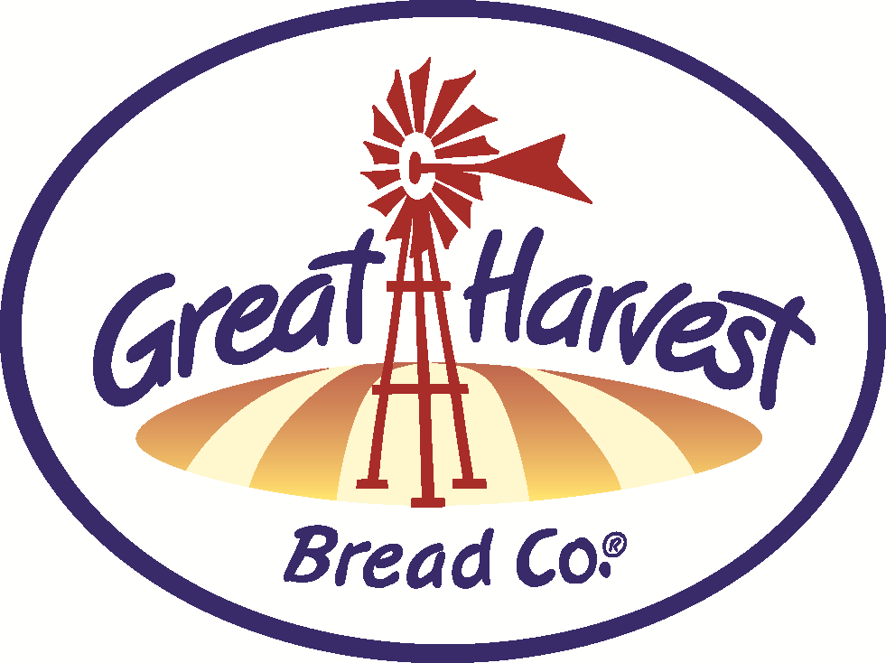
HANDCRAFTED

Breads & Goodies


BAKE SCHEDULE NOVEMBER

Purchase three Frontier Soup Mixes and get a fourth
pack of equal or lesser value free!

Caramel Apple & Pumpkin Chocolate Chip quick bread…we suggest you get both!

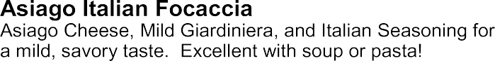
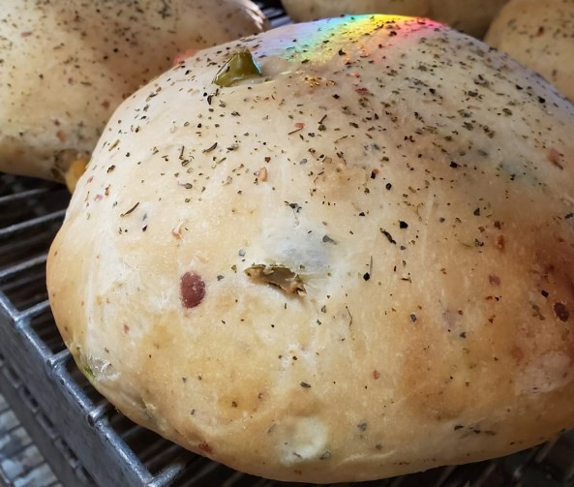

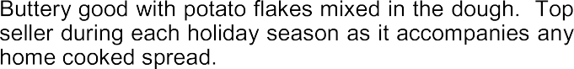

Try our amazing sandwiches with a tray of our delicious sweets for your next team meeting or group get-together.

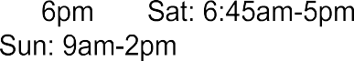

BREADS (special bake days indicated)
Cinnamon Chip
Chips baked right into a toaster-ready loaf!

Honey Whole Wheat
Simply whole wheat, honey, water, yeast & salt.
Old Fashioned White
Exceptionally simple bread!
Dakota
Nutritious seeds add that special crunch to our whole grain wheat dough!
Cheddar Garlic
Packed with cheddar and baked kick of garlic. Also try our Jalapeno variation for some added heat!
Low Carb Whole Wheat
Low calorie, low carb, whole grain & high protein!
Low Carb Nut & Seed
Added nuts & seeds (more protein!)
Oregon Herb
Taste similar to an everything bagel...onion, dill savory.
Sourdough -TUE, FRI (except holiday week)
Challah - FRI (bake day)
Enriched & braided - perfect French Toast!

Virginia Rolls
Light and buttery with potato & light wheat

WEEKEND BAKER'S SPECIALS�

Pizza Bread -(Oct 30th-Nov 2nd) & (28th- 30th)
Three varieties to choose from; Meat, 3-Cheese, or Spinach & Garlic...all with pizza sauce & spices rolled into the dough!

Orange Blossom - (Nov 6th-9th)
Pureed navel oranges baked in the dough with a sweet, crunchy hat!

White Chocolate Cherry Swirl - (13th-16th)
Super Decadent...a customer favorite!

BREADS - SWEET
Cinnamon Swirl - FRI (bake day)
Favorite breakfast bread. Made from Challah dough!
Monkey Bread- A fun, cinnamon-sweet, pull-apart bread!
SANDWICH SPECIALS
Smoked Turkey Classic

Premium smoked turkey breast with your choice of cheese on fresh-baked GH Bread. Get your Bird Fix early!
Buy this sandwich and get a bag of chips FREE!

SWEETS
CINNAMON ROLLS (they’re HUGE!)

SCONES Best in Town! Blueberry - Best Seller! Cinnamon Chip/Choc. Chip
Savory Ham & Cheddar (nice breakfast)

COOKIES
Oatmeal Choc. Chip & Snickerdoodle
Ginger Molasses
Pumpkin Spice with White Choc. Chips
Cherry Almond Shortbread- Choc. Dipped!

BARS- Fruit and Pumpkin Spice varieties

GLUTEN FREE
Bread - Avail. Frozen daily
Teacakes and Cookies

This symbol means it's made with our from-scratch, whole grain flour that we grind fresh daily!

