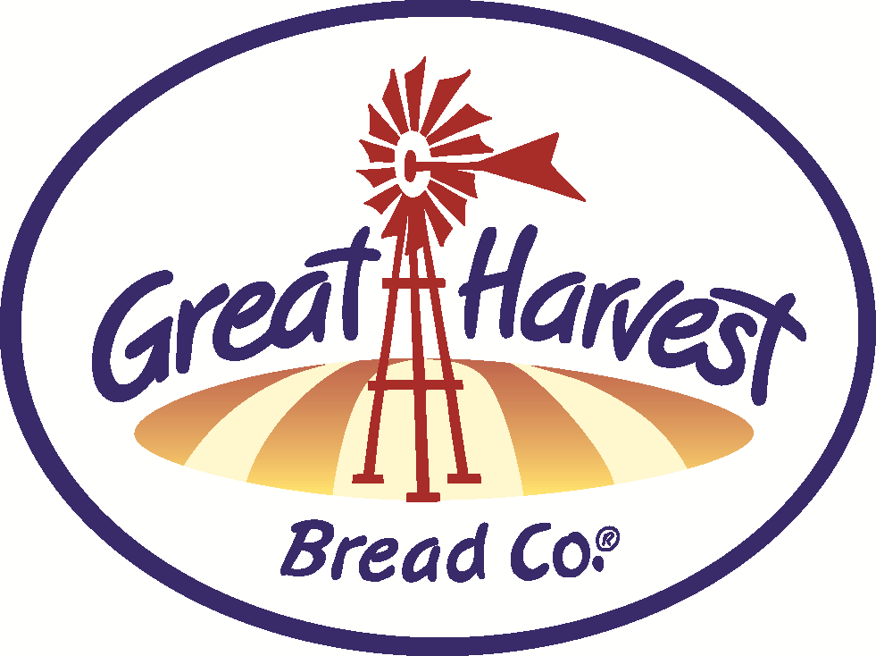
HANDCRAFTED
Breads & Goodies
BAKE SCHEDULE


JANUARY
If your birthday is in January, come in for a free single cookie on your special day! Proof of birthday required.
MARDI GRAS KING CAKES – TUES, FRI
A cinnamon, sweet and festive tradition, complete with colorful beads and plastic baby so you can decorate on your own safely. Available with or without pecans. You would be hard-pressed to find one as good as ours! Available through the Carnival season.


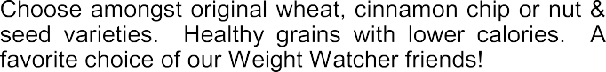

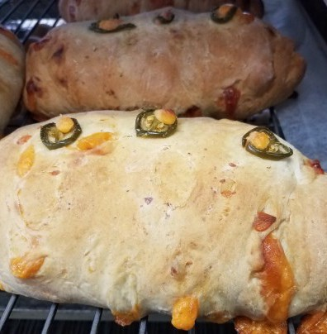
Our savory breads are packed with flavor and loaded with cheese. Choices include Cheddar Garlic, Cheddar Gar-lic Jalapeno (pictured) , or Asiago Italian Focaccia.

Try our amazing sandwiches with a tray of our deli-cious sweets for your next team meeting or group get-together.

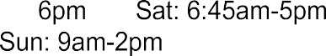

BREADS

Honey Whole Wheat
Just whole wheat, honey, water, yeast & salt
Old Fashioned White
Traditional white bread made from scratch!
Dakota
Nutritious seeds for that crunch
Low Carb Whole Wheat
Low calorie, low carb & high protein!
Low Carb Nut & Seed
Added nuts & seeds (more protein!)
Oregon Herb
Taste similar to an everything bagel.
Cinnamon Chip Bread & Monkey Bread Actual cinnamon chips baked into our toaster or pull-apart loaves.
Challah - FRI
Enriched & braided - perfect French Toast!
Sourdough- TUE, FRI

Virginia Rolls
Light and buttery with potato & light wheat

WEEKEND BAKER'S SPECIALS-:

Pizza Bread – 1st & 5th full weekend
Three varieties to choose from; Meat, 3-Cheese, or Spinach & Garlic...all with pizza sauce & spices rolled into the dough!
Orange Blossom - 2nd weekend Pureed Navel Oranges & crunchy sweet topping! Tuscan Tomato- 3rd weekend Excellent with Soup and makes a great grilled cheese!

White Chocolate Cherry Swirl- 4th weekend
Super Decadent, a customer favorite!

BREADS - SWEET
Cinnamon Swirl - FRI
Favorite breakfast bread. Made from Challah dough!

SANDWICH SPECIALS

Spicy Apple Bacon Grilled Cheese!
Melted cheddar and provolone, thin granny smith apple, bacon and pepper jelly

Buy this sandwich and get free chips.

SWEETS

CINNAMON or PECAN ROLLS

SCONES Best in Town!
Blueberry
Cinnamon Chip/Choe. Chip Savory Ham & Cheddar

COOKIES
Oatmeal Choc. Chip, Snickerdoodle and Cherry Almond Shortbread

BARS Fruit Harvest Bars-Weekends

GLUTEN FREE
Bread - Avail. Frozen any day.
Teacakes or Cookies- Everyday

This symbol means it's made with our from-scratch, whole grain flour
that we grind fresh daily!

