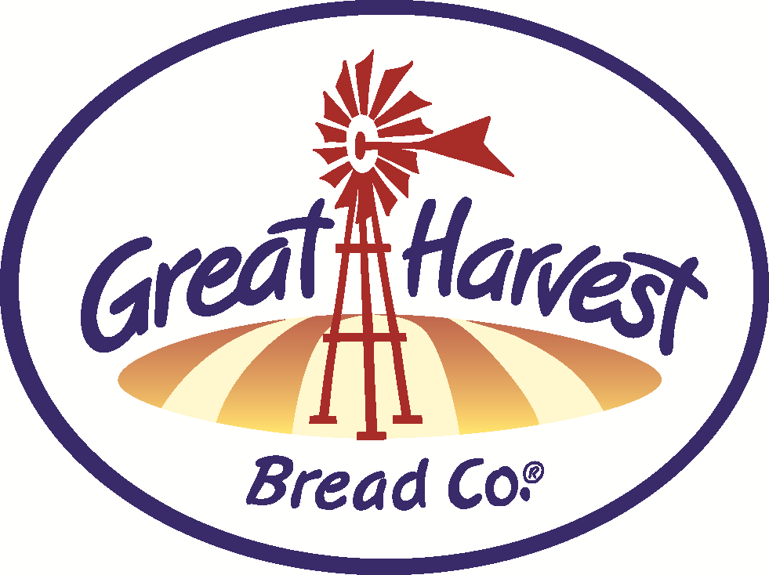


Create a GIFT BASKET valued over $50 and get 10% off!

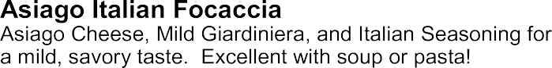
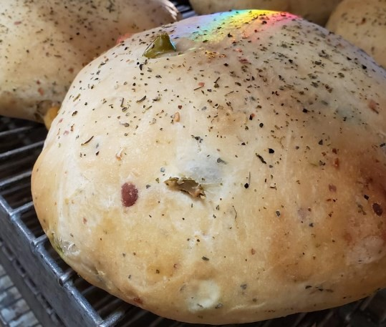
HANDCRAFTED
Breads & Goodies

BAKE SCHEDULE DECEMBER

A bounty of Eastern European delicate swirl breads in three varieties; Chocolate, Toffee Pecan or Blueberry Lemon.

Try our amazing sandwiches with a tray of
delicious sweets for your next team meeting or group get-together.



BREADS (special bake days indicated)
Cinnamon Chip
Chips baked right into a toaster-ready loaf!

Honey Whole Wheat
Simply whole wheat, honey, water, yeast & salt.
Old Fashioned White
Exceptional white bread from scratch!
Dakota
Nutritious seeds add that special crunch to our whole grain wheat dough!
Cheddar Garlic
Packed with cheddar and a kick of garlic baked in. Also try our Jalapeno variation for some added heat!

SANDWICH SPECIALS

BLT

Simple Bacon Goodness on awesome fresh wholesome bread!

Buy this sandwich and get a bag of chips FREE!


Low Carb Whole Wheat
Low calorie, low carb, whole grain
Low Carb Nut & Seed

& high protein!

SWEETS

CINNAMON ROLLS (they’re HUGE!)

Added nuts & seeds (more protein!)
Oregon Herb
Taste similar to an everything bagel...onion, dill savory.
Sourdough - TUE, FRI (bake days)
Challah - FRI (bake day)
Enriched & braided - perfect French Toast!

Virginia Rolls
Light and buttery with potato & light wheat

SCONES Best in Town! Blueberry - Best Seller! Cinnamon Chip/Choe. Chip
Savory Ham & Cheddar (nice breakfast)

COOKIES

WEEKEND BAKER'S SPECIALS� Oatmeal Choe. Chip & Snickerdoodle

Pizza Bread - (Nov 28thNov 30th) & (Dec 26th-28th) Three varieties to choose from; Meat, 3-Cheese, or Spinach & Garlic...all with pizza sauce & spices rolled into the dough!

Orange Blossom - (Dec 4th-7th)
Pureed navel oranges baked in the dough with a sweet, crunchy hat!

Mediterranean Loaf - (11th-14th)
Gruyere cheese and caramelized onions make this savory bread unique.

White Chocolate Cherry Swirl - (18th -21st)
Super Decadent...a customer favorite!

BREADS - SWEET
Cinnamon Swirl - FRI (bake day)
Favorite breakfast bread. Made from Challah dough!
Monkey Bread- A fun, cinnamon-sweet, pull-apart bread!
Ginger Molasses
Christmas Tree Sugar Cookies
Chocolate Mint Cookies
Cherry Almond Shortbread- Choe. Dipped!

BARS- Fruit varieties

GLUTEN FREE
Bread - Avail. Frozen daily
Teacakes and Cookies

This symbol means it's made with our from-scratch, whole grain flour
that we grind fresh daily!

